Call Centre Dashboard – Project Report

Introduction
In this project, I developed a Call Centre Dashboard using Microsoft Excel to analyze call performance, customer feedback, response time, and call distribution across different centers and channels.

Dashboard Overview

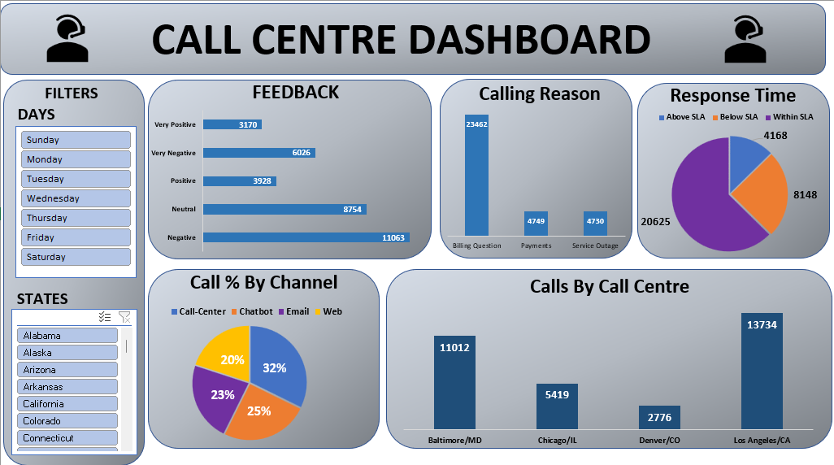
The dashboard allows filtering by:
- Days (Sunday to Saturday)
- States
This helps in analyzing call data for specific time periods and locations.
It displays KPIs and different charts to understand feedback trends, response performance, and operational workload.

Detailed Dashboard Analysis

1️ Customer Feedback

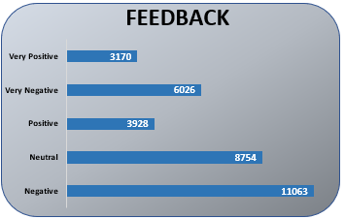
The feedback section shows five categories:
- Very Positive – 3170
- Positive – 3928
- Neutral – 8754
- Negative – 11063
- Very Negative – 6026
From the analysis, negative and neutral feedback responses are higher compared to positive ones. This indicates that customer service quality needs improvement.

2️ Calling Reason

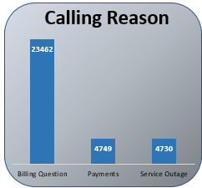
The calling reasons are categorized as:
- Billing Question – 23,462 (Highest)
- Payments – 4,749
- Service Outage – 4,730
Most customers contact the call centre for billing-related issues. This suggests that billing processes or clarity may require improvement

3️ Response Time (SLA Performance)

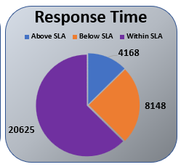
The response time pie chart shows:
- Within SLA – 20,625
- Below SLA – 8,148
- Above SLA – 4,168
Majority of the calls are handled within SLA, which indicates good operational performance. However, some calls exceed SLA, which should be minimized.

4️ Calls% by Channel

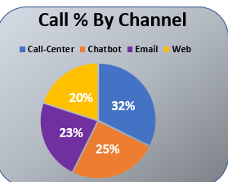
Call distribution by communication channel:
- Call Center – 32%
- Chatbot – 25%
- Email – 23%
- Web – 20%
The highest interaction happens through traditional call center mode, but digital channels like chatbot and email also have strong participation

5️ Calls by Call Centre Location

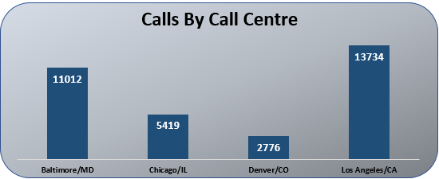
- Los Angeles, CA – 13,734 (Highest)
- Baltimore, MD – 11,012
- Chicago, IL – 5,419
- Denver, CO – 2,776
Los Angeles handles the highest call volume, while Denver handles the lowest. This helps management understand workload distribution among centres.

Tools & Techniques Used
- Microsoft Excel
- Pivot Tables
- Pivot Charts
- Slicers
- Data Cleaning and Formatting

Conclusion
The Call Centre Dashboard provides a complete overview of customer interaction and operational performance. It helps in identifying problem areas such as billing complaints and negative feedback.
By using this dashboard, management can focus on improving service quality, reducing SLA violations, and balancing workload among different centres.

